**2. GIT exercise**

1. Create a repository on Github called favorite-cmd-commands, make sure to check the checkmark about including a README file
2. Clone that repository (Google how to clone a repository).
3. Edit the README.md markdown file.
4. Add bash commands that you like (at least 3) and style them as headers.
5. Provide a short description (20 characters~) for each.
6. Then git add, git commit and git push the file to your GitHub repository.

**1-Creating a reposotory**

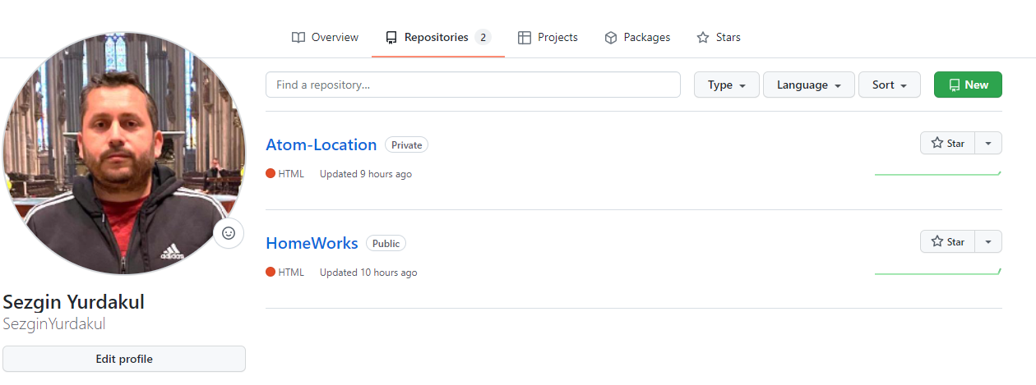

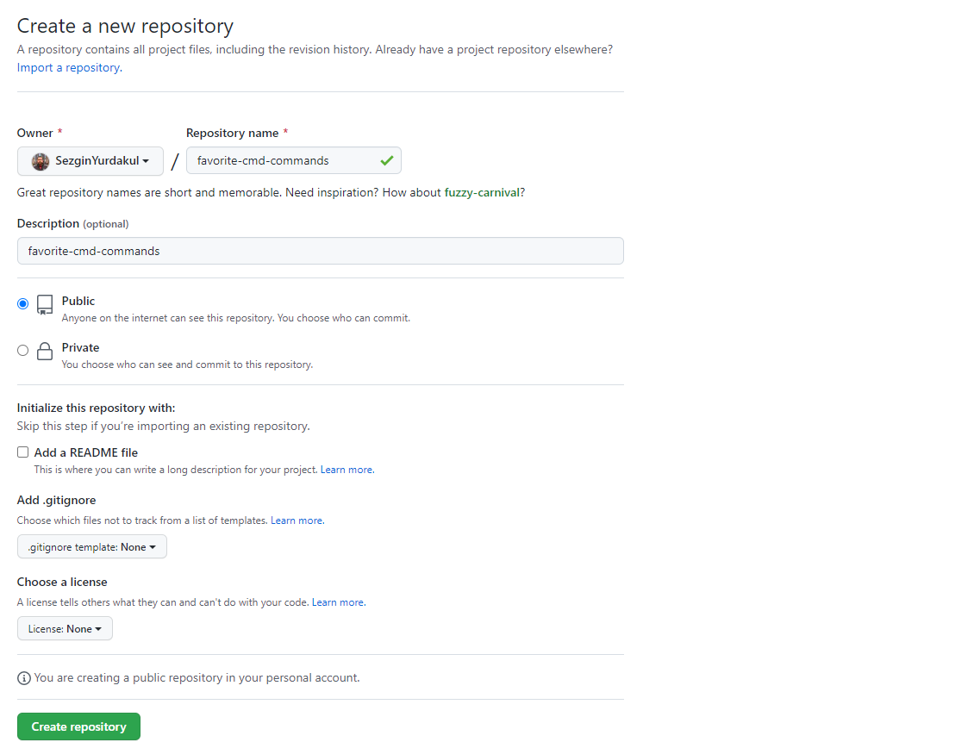

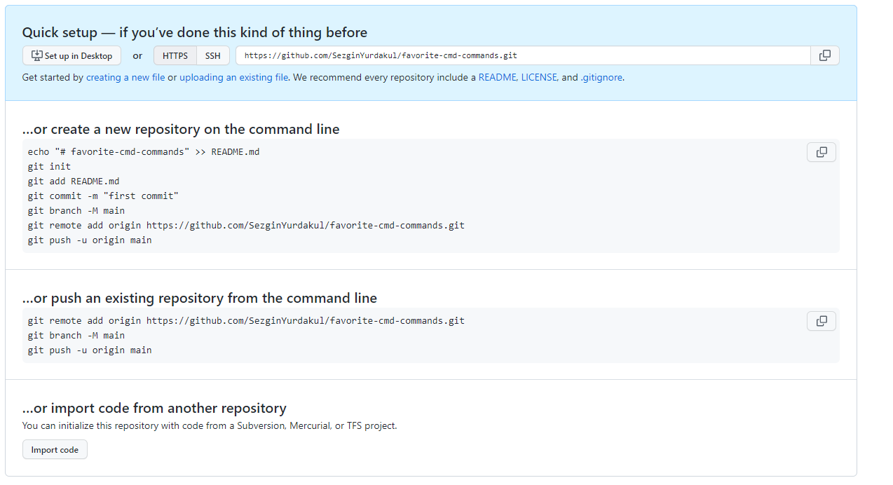

**2- Cloninnig the reposotory**

Sezgin@DESKTOP-F8VRO1C MINGW64 ~/Desktop/HackYourFuture/HomeWorks/Week2 (master)

$ git clone https://github.com/SezginYurdakul/favorite-cmd-commands.git

Cloning into 'favorite-cmd-commands'...

warning: You appear to have cloned an empty repository.

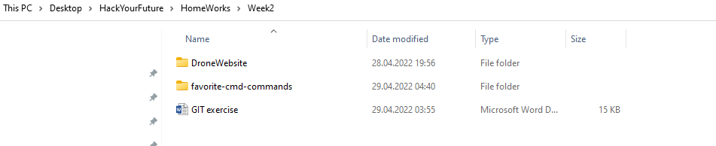

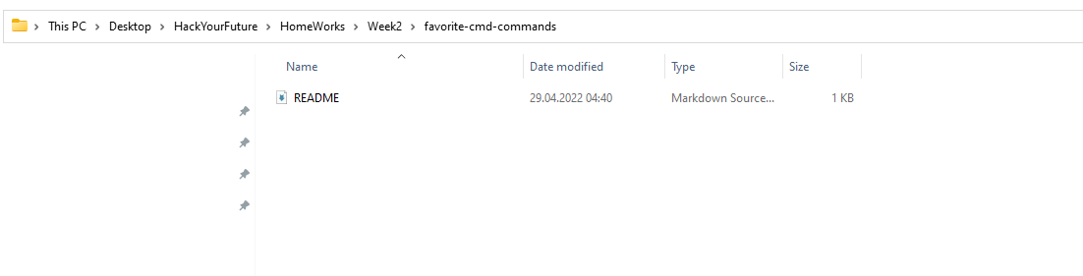

**3-Modifying README.md and commited 3 times**

Sezgin@DESKTOP-F8VRO1C MINGW64 ~/Desktop/HackYourFuture/HomeWorks/Week2/favorite-cmd-commands (main)

$ git status

On branch main

Your branch is up to date with 'origin/main'.

Changes not staged for commit:

(use "git add <file>..." to update what will be committed)

(use "git restore <file>..." to discard changes in working directory)

modified: README.md

no changes added to commit (use "git add" and/or "git commit -a")

Sezgin@DESKTOP-F8VRO1C MINGW64 ~/Desktop/HackYourFuture/HomeWorks/Week2/favorite-cmd-commands (main)

$ git commit . -m "First Topic in HYF is HTML notes are added"

[main 44e07c0] First Topic in HYF is HTML notes are added

1 file changed, 3 insertions(+), 2 deletions(-)

Sezgin@DESKTOP-F8VRO1C MINGW64 ~/Desktop/HackYourFuture/HomeWorks/Week2/favorite-cmd-commands (main)

$ git commit . -m "Second topic in Hack Your Future is CSS"

[main 4542c71] Second topic in Hack Your Future is CSS

1 file changed, 3 insertions(+), 1 deletion(-)

Sezgin@DESKTOP-F8VRO1C MINGW64 ~/Desktop/HackYourFuture/HomeWorks/Week2/favorite-cmd-commands (main)

$ git commit . -m "Third topic in Hack Your Future is Java Script"

[main 9f1d93c] Third topic in Hack Your Future is Java Script

1 file changed, 2 insertions(+)

**4-Pushing all commits to GitHub**

Sezgin@DESKTOP-F8VRO1C MINGW64 ~/Desktop/HackYourFuture/HomeWorks/Week2/favorite-cmd-commands (main)

$ git push

Enumerating objects: 11, done.

Counting objects: 100% (11/11), done.

Delta compression using up to 8 threads

Compressing objects: 100% (6/6), done.

Writing objects: 100% (9/9), 932 bytes | 932.00 KiB/s, done.

Total 9 (delta 1), reused 0 (delta 0), pack-reused 0

remote: Resolving deltas: 100% (1/1), done.

To https://github.com/SezginYurdakul/favorite-cmd-commands.git

ac529bf..9f1d93c main -> main

